🗓️ 10-Day Workflow Plan
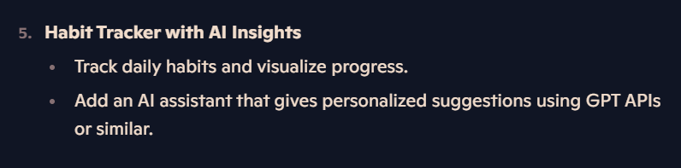

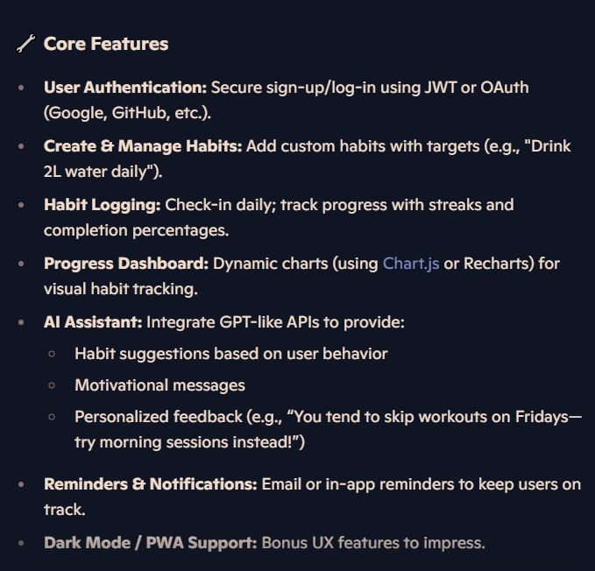

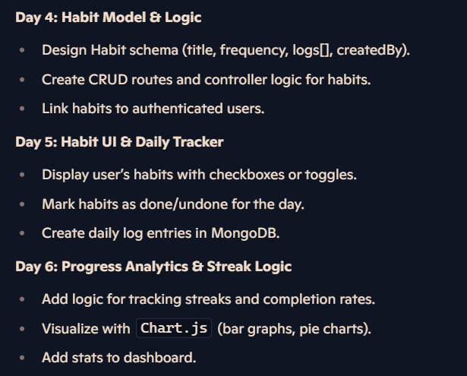
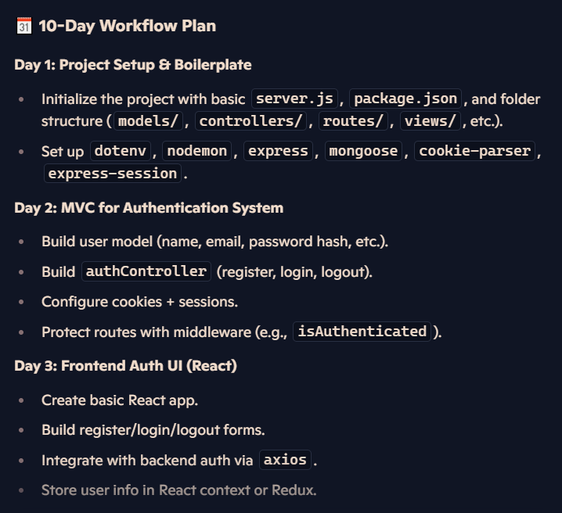

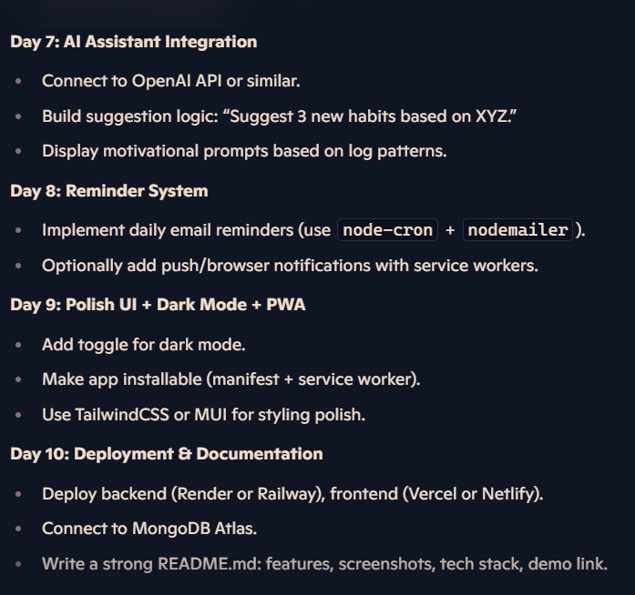


This schedule gives you real-world depth while letting each day feel focused and manageable. Want me to help you write a README intro, set up GitHub Actions for CI/CD, or brainstorm habit ideas for demo users? Just say the word.

LINK
https://copilot.microsoft.com/shares/DHG7euWPAnwdTKdrk8dnt

README.md
